July 2021
Sunday | Monday | Tuesday | Wednesday | Thursday | Friday | Saturday
MY BEST SUMMER |  |  |  | 1  Play in a pool | 2  play basketball | 3  Play football
4  Play video games | 5  Go to the park | 6  Go to see my best friend | 7  Go to the Movies | 8  Go to my grammas | 9  Go to buy some video games | 10  Go shopping
11  I am going to play a card game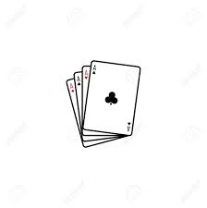 | 12  I am going to play on my bike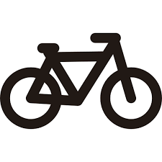 | 13  I am going to play on my skateboard | 14  I am going to play with my dog | 15  I am going to go get some new shoes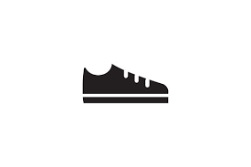 | 16  I am going to be coloring | 17  I am going to play on my phone
18  I am going to be board | 19  I am going to just run around | 20  I am going to clean. | 21 | 22 | 23 | 24
25 | 26 | 27 | 28 | 29 | 30 | 31

